Remote QA Field Reviews/Inspections
Draft – 01
This proposal is being issued on behalf of the Standards Committee of the Northeast Home Energy Rating System Alliance, which represents more than 260 Raters and 11 Providers from New Jersey to Maine.

Amendment: Remote QA Field Reviews/Inspections
Proponent: RESNET SDC900
Applies to: RESNET MINHERS Chapter 9
904.3.3.1.5 "Remote" QA Field reviews. All HERS Raters must annually receive a minimum of one (1) on-site, in-person QA Field review on total annual Confirmed, Threshold or Sampled ratings completed. All RFIs must annually receive a minimum of one (1) on-site, in person QA field review on the total annual pre-drywall or final field inspections completed. All other QA Field reviews, for completed and pre-drywall homes, may be performed using a "remote" QA Field review methodology specified by RESNET.
Proposed Amendment:
904.3.3.1.5 "Remote" QA Field reviews. All HERS Raters must annually receive a minimum of one (1) on-site, in-person QA Field review on total annual Confirmed, Threshold or Sampled ratings completed. All RFIs must annually receive a minimum of one (1) on-site, in-person QA field review on the total annual pre-drywall or final field inspections completed. All other QA Field reviews, for completed and pre-drywall homes, may be performed using a "remote" QA Field review methodology specified by RESNET. Providers are not required to provide a remote option for Field QAs but may require on-site QA inspections, when necessary, as determined by the Provider or at the request of the Rater or RFI.
Background/Rationale:
Since the March 2020 adoption of the Emergency COVID-19 provisions for Temporary Remote QA Field Observations, both the necessity for and capacity to effectively perform the required associated tasks has increased greatly. We now have more than 2 years of experience and data to effectively assess the social, economic, and environmental benefits of performing remote inspections.
Social Impacts: Many families were forced to change their work/life habits to accommodate changes due to the pandemic. The ability to have more of the workforce able to work from a home or local office setting has allowed for changes in roles that may not be easily accommodated if forced to return to field-forward operations.
Remote inspections may also allow for additional workforce expansion to federally protected status categories (EEOC) such as physically impaired employees who may not be able to easily access inspection areas.
Economic Impacts: The emergency provisions were put into place in response to a specific environmental event (COVID-19 pandemic). Since our world continues to “change dramatically all around us”, we are experiencing greater economic stress thus requiring an increased need for cost reduction strategies for both individuals and businesses. The immediate and most obvious economic benefits of remote inspections/QA are directly related to less road travel time, fuel costs, and scheduling flexibility (not having to use fuel and time to get to a site that’s not ready). Additional economic benefits may come in the form of discounted rates, and the ability to automate systems such as online inspection booking.
The use of this Standard as written is advantageous only to those firms performing more than 100 ratings per year. Smaller firms are left with increased scheduling difficulties, due to less inventory to choose from, and decreased profitability.
Environmental Impacts: Direct environmental benefits of remote inspections lie both in the reduction of volatile emissions and decreased risk of illness due to human-to-human contact.
Much of our work is based on reducing environmental impacts through increased home performance, better building materials, and more effective work practices. CO2 emissions represented 79% of Greenhouse Gas Emissions in 2020 (see charts below). The Commercial and Residential sectors represent 13% of U.S. 2020 Greenhouse Gas Emissions by economic sector with transportation representing 27%. The EPA reported an 11% decrease in CO2 emissions from 2019 to 2020 “primarily due to a 13% decrease in transportation emissions driven by decreased demand due to the ongoing COVID-19 pandemic.”
The use of remote inspections increases our environmental reach with a direct impact on the largest economic sector, transportation. One may argue that investing in low emissions (hybrid & electric) vehicles would be a good strategy. As much as this may have a direct impact on localized vehicle emissions, much of the greenhouse gas emissions are merely deferred to the second largest economic sector, electricity. Until we increase our green electricity generation and invest in better transmission strategies, remote inspections can yield a greater, more immediate impact on greenhouse emissions.
Additional Benefits: There are many times when a Rater, RFI, or other stakeholders are present at the time of inspection, they often have questions regarding equipment, standards, etc. With remote inspections/QA, the QAD or Technical Advisor can access various resources to answer questions in real-time, therefore reducing the potential for additional site visits and communication lag resulting in a more seamless and satisfactory customer service experience.
Removing the QAD from on-site foot traffic also allows for greater scheduling flexibility increasing the ability to perform random selection of properties to meet RESNET and other Program requirements.
Summary: Allowing the ongoing use of Remote QA and Inspections as outlined in the current emergency provisions will not only serve to meet our goals of better serving our communities through better performing homes, we can also increase our reach into employment sectors and geographic regions not previously accounted for.
As an industry, it has always been our mission to reduce social, economic, and environmental devastation through increased training, technological advances in building materials/work practices, and better-performing structures. To return to re-tracing the steps of inspectors and trades who are already required to be on site would be a major step backward in a field that strives so hard to eke out every possible means to conserve energy, reduce end-user costs, and create better living and work environments.
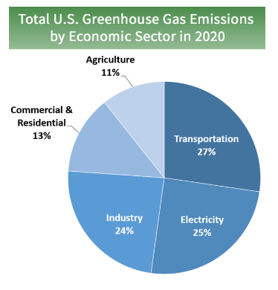
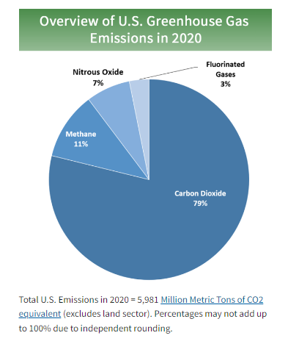
Many companies have used remote services for technical support (field tech equipment diagnostics, etc.), inspections, training, medical support, and more. As our industry continues to grow it’s not just a necessity but an obligation to our industry and our communities to continue to allow for the use of 100% remote services for quality assurance field reviews, inspections and training.

https://www.resnet.us/about/us/resnet-covid-19-updates/
https://www.epa.gov/ghgemissions/inventory-us-greenhouse-gas-emissions-and-sinks#:~:text=In%202020%2C%20U.S.%20greenhouse%20gas,sequestration%20from%20the%20land%20sector).

